H.T No
Regulations:
A15

Sreenidhi Institute of Science and Technology
(An Autonomous Institution)
Code No: 5A242 Date: 14-July-2021 (AN)

B.Tech I-Year II- Semester External Examination, July - 2021 (Supplementary)
NETWORK ANALYSIS (ECE and ECM)

Time: 3 Hours Max.Marks:75

Note: a) No additional answer sheets will be provided.
b) All sub-parts of a question must be answered at one place only, otherwise it will not be valued.
c) Missing data can be assumed suitably.

ANSWER ANY 5 OUT OF 8 QUESTIONS. EACH QUESTION CARRIES 15 MARKS.

Bloom's Cognitive Levels of Learning (BCLL)

Remember | L1 | Apply | L3 | Evaluate | L5
Understand | L2 | Analyze | L4 | Create | L6

 |  |  | BCLL | CO(s) | Marks
1. | a) | Mention the various types of sources? Discuss them with necessary circuit diagram. | L2 | CO1 | [8M]
 | b) | Obtain the current I in 12Ω resistor, reducing the network shown below into a single loop network by successive source transformation.  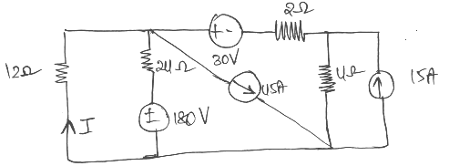 | L3 | CO1 | [7M]
2. | a) | For the electrical network shown in the below figure draw its topological graph and obtain its incidence matrix, tie-set matrix, link current transformation equation and branch currents.  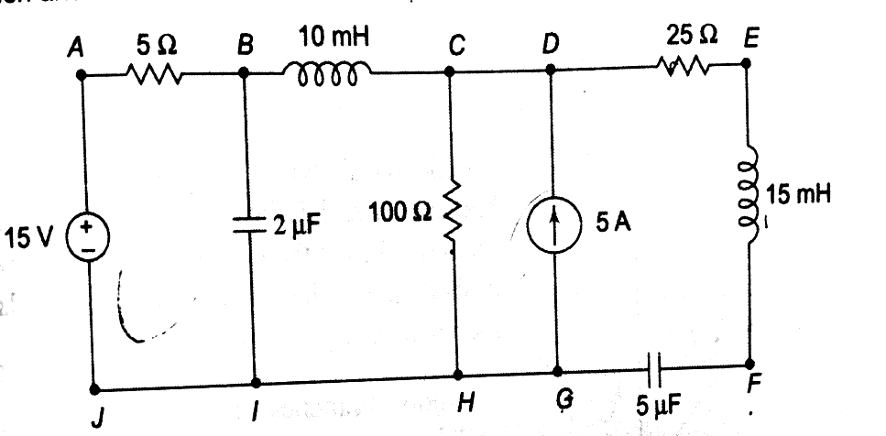 | L4 | CO2 | [8M]
 | b) | Explain the procedure to obtain the incidence matrix and properties of incidence of matrix. | L2 | CO2 | [7M]
3. | a) | A resistor of 100Ω is connected in series with a 50μF capacitor. Find the effective voltage applied to the circuit at a frequency of 50Hz. The effective voltage across the resistor is 170V. Also determine voltage across the capacitor and phase angle. | L3 | CO3 | [8M]
 | b) | Show that the resonant frequency ω₀ of an RLC series circuit is the geometric mean of ω₁ and ω₂, the lower and upper half power frequencies respectively. | L4 | CO3 | [7M]
4. | a) | The circuit shown below has resistance R which absorbs maximum power. Compute the value of R and maximum power.  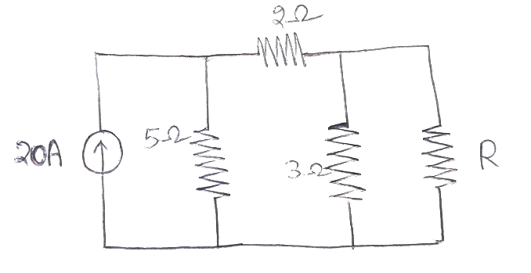 | L4 | CO4 | [8M]
 | b) | Explain the steps to apply Thevenin’s Theorem and the Thevenin’s equivalent circuit. | L2 | CO4 | [7M]
5. | a) | Derive the symmetry and reciprocity conditions for ABCD parameters and h-  parameters. | L3 | CO5 | [8M]
 | b) | The Z-parameters of a two-port network shown in figure are Z₁₁=Z₂₂=10Ω,  Z₂₁=Z₁₂=4Ω. If the source voltage is 20V, determine I₁, V₂, I₂ and input impedance.  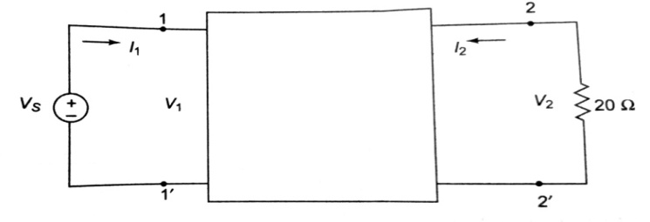 | L4 | CO5 | [7M]
6. | a) | Voltage across capacitor and current through an inductor cannot change  instantaneously. Justify | L4 | CO6 | [8M]
 | b) | A series RL circuit with R=30Ω and L=15H has a constant voltage V=60V  applied at t=0 as shown in figure. Determine the current i, the voltage across  resistor and voltage across the inductor.  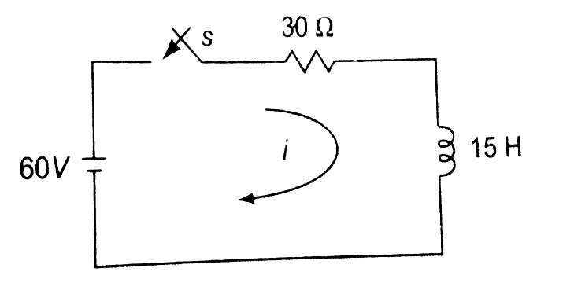 | L3 | CO6 | [7M]
7. | a) | Derive the expression for energy stored in an ideal inductor. | L3 | CO1 | [5M]
 | b) | Obtain the dual of the network for the network given below.  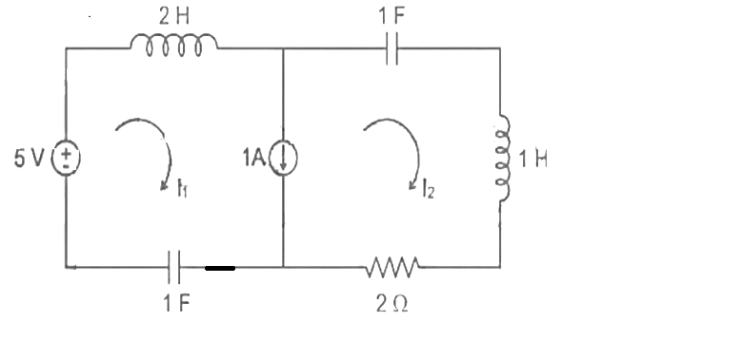 | L4 | CO2 | [5M]
 | c) | Obtain an expression for coefficient of coupling. | L4 | CO3 | [5M]
8. | a) | Calculate the current I shown in the below figure using Milliman’s Theorem.  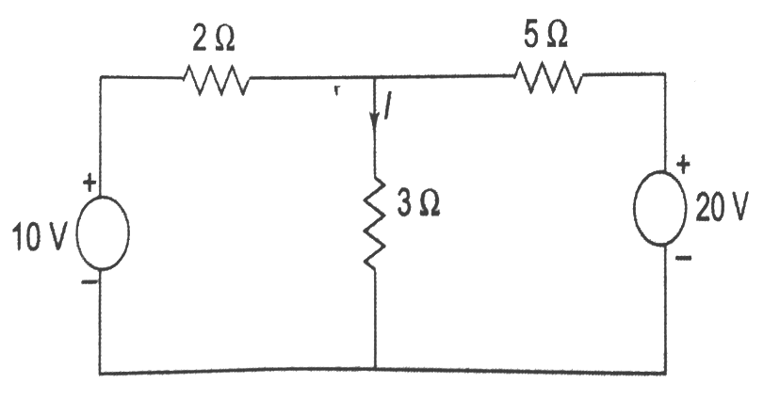 | L5 | CO4 | [5M]
 | b) | Differentiate between active and passive filters. | L3 | CO5 | [5M]
 | c) | Find the laplace transform of function f(t)= tsin2t | L3 | CO6 | [5M]
-- 00 -- 00 –

